YOUR PROFESSIONAL DEVELOPMENT PLAN: MAPPING YOUR JOURNEY TO CAREER HAPPINESS

Do you have your resume in hand? Think about all of your professional experience, both work and school.

You are ready to get started.

WHAT IS A PD PLAN AND WHY BOTHER?

DETERMINE WHO YOUR ARE

- What am I really good at?

- What are my likes? Usually the stuff I am good at, but is there more?

- What do I dislike?

- What interests me?

- What are my strengths?

- What am I passionate about?

- What are my values?

- What do I struggle with?

- What skills do I have

- What’s my experience

- My personality

Useful Guide:
Career Planning Resource from University of Washington, Professional & Organizational Development https://hr.uw.edu/pod/wp-content/uploads/sites/10/2016/02/Career-Planning-Resource.pdf

Where do you want to be in 5 years? Dream BIG! Write it down.

SELF –ASSESSMENT- TESTING TOOLS

Myers-Briggs https://www.16personalities.com/

CliftonStrengths https://www.gallupstrengthscenter.com/

DISC
https://www.123test.com/disc-personality-test/

The Big Five
https://www.123test.com/disc-personality-test/

What do the tests say about you? Food for thought?

DO A PERSONAL SWOT

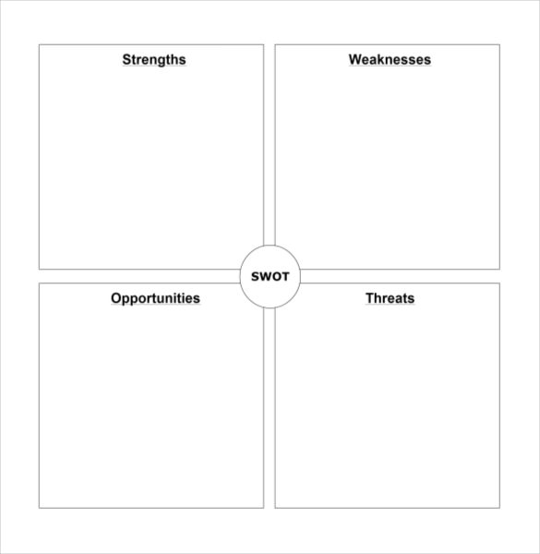

CONDUCT A GAP ANALYSIS

DEFINE THE IDEAL POSITION

WHAT ARE YOUR CAREER ANCHORS?

Geography:

Lifestyle:

Job Security:

Service and Work:

Employer (culture, size, benefits):

Personal situation (present and future):

FILLING THE GAPS

Education – what do I need to learn? Formal and informal opportunities.

On the job training - what are my options?

Networking opportunities

Volunteering and associations

Job Changes

COMPLETE YOUR OWN CAREER/FUTURE PLAN

The template I used is at https://www.slideshare.net/uolssds/career-plan-example

IMPLEMENT YOUR PLAN

Keep your goals front of mind

Prioritize

Use technology
- Goalmigo
- Stickk
- Any
- Wunderlist
- The Passion Planner Stay accountable

Keep a journal

Reward yourself

EVALUATE PROGRESS

Adjust as you go Be Flexible

WE ARE ALL DIFFERENT – FOUR CAREERS CONCEPT – WHICH ONE ARE YOU?

The Four Career Concepts: Managers can learn how to better develop their people by learning how they're motivated, by Robert N. Llewellyn, September 1, 2002

The following is an excerpt:

Linear. To the person motivated by the linear concept, success only comes from moving up the corporate ladder. While prevalent in the United States, this proves to be a difficult concept to yield continuing success. Movement up the organizational pyramid provides fewer positions into which to advance. Many who carry the linear concept are frustrated. Many leave positions of influence when they become “topped out.” The “de-layering” of organizational levels of the 1990s left many linears disillusioned. For many, it is an emotionally brutal concept.

Expert. Success for the person motivated by the expert concept is being known as the best among his or her peers. This includes the craft worker who yearns to be the best welder at Amalgamated Inc. It is also the trial lawyer garnering community recognition for a high-profile case, the surgeon with national recognition for an innovative procedure or the accountant with the most knowledge in the department of accounting rules. Those who carry the expert concept may have been told in their youth to “grow up to be good at something.” Their parents or grandparents may have been influenced by the Great Depression, during which the employees who kept their jobs were often the ones with the best skills.

Spiral. Success is being able to move from one position to a related but often broader position, usually every five to 10 years. Broadening is the key. A spiral’s parents may have taught him to be “well rounded.” New positions are a natural extension of the prior work. This is the engineer who migrates into project management and then to capital budgeting and eventually to corporate budgeting functions. Spirals amass a vast amount of knowledge and experience.

Many spirals in mid-career feel a strong desire to share the massive knowledge with others. This leads some spirals to leave large companies to become consultants or teachers.

Roamer. Success to the roamer is being able to change jobs often. Movement is more frequent than spirals, perhaps every two to three years, and the succeeding jobs are often unrelated to past professional experiences. A roamer may move from funeral director to draftsman. These are often people from the extremes of economic backgrounds who don’t value security. They either were raised in an upper-economic stratum and presume money will always be there or were in a poorer economic environment and know they can survive on very little.

For the full article go to: https://www.shrm.org/hr-today/news/hr-magazine/pages/0902tools.aspx

